

Davenham Church of England Primary School

“Working Together, Playing Together, Serving God and Serving Others”
“…encourage one another and build each other up…”
1 Thessalonians 5:11.

POLICY FOR ADMISSIONS 2023 – 2024
including Covid 19 variation made July 2020 to admissions arrangements for Reception September 2023

Parents should be aware before applying that in this school RE, Collective Worship and our whole ethos are based on the teachings of the Church of England.

Applications for admission to the school should be made on-line via the Cheshire West and Chester Council Admissions Website and in accordance with guidance and timescales provided. It is not normally possible to change the order of your preferences for schools after the January closing date.
Email confirmation or letters informing parents of whether or not their child has been allocated a place in Reception will be sent out by the Local Authority in April 2023. Parents of children not admitted will be informed of the reason and offered an alternative place by the Authority.
The number of places available for admission to the Reception class in the year 2023 will be a maximum of 45.

This arrangement follows consultation between the governing body, the Diocesan Board of Education, Local Authorities and other admissions authorities in the area. The Governing Body will not place any restrictions on admissions to the reception class unless the number of children for whom admission is sought exceeds this number. By law, no infant class may contain more than thirty children.
The Governing Body operates a system of equal preferences under which they consider all preferences, in order equally and the Local Authority allocates places according to the school’s policy. In the event that there are more applicants than places, the Governing Body will allocate places using the following criteria, which are listed in order of priority:

- A “Looked after Child” (LAC) or a child who was previously looked after by an English Local Authority but ceased to be so because they were adopted or became subject to a child arrangement or special guardianship order. A looked after child is a child who is (a) in the care of the local authority or (b) being provided with accommodation by a local authority in the exercise of their social services functions as defined in Section 22(1) of the Children Act 1989.

- Children with special medical or social circumstances affecting the child where these needs can only be met at this school. (see note a )

- Children whose parent/s are faithful and regular worshippers of St Wilfrid’s Parish Church, (see note b)

- Children who have a sibling in school who will still be attending school the in following year (see note c)

- Children resident within the Admission Priority catchment area of the school (see note d)

- Children resident within the Ecclesiastical Parish of Davenham (see note e)

- Children resident outside the Parish nearest to the school. Distances are measured using Ordnance Survey mapping in conjunction with Local Land and Property Gazetteer (LLPG) to identify each property and each school. A straightline measurement in miles is taken from the place of residence to the preferred school to calculate the distance.

In the event of a tiebreak, a random allocation will be undertaken

If there are not enough places to admit all applicants meeting any one criterion, the governors will apply the subsequent criteria, in order of priority, to all these applicants.

Notes

- Professional supporting evidence from e.g. a doctor, psychologist, social worker, is essential if admission is to be made under the criterion for special medical or social circumstances, and such evidence must set out the particular reasons why the school is question is the most suitable school and the difficulties which would be caused if the child had to attend another school.

(b) By “faithful & regular”, we mean attendance at St Wilfrid’s Parish Church on average a minimum of 2 services per month for at least the previous year prior to the closing date for applications. A parent / carer is any person who has parental responsibility or care of the child. Where admission arrangements refer to ‘parent’s attendance at church’, it is sufficient for just one parent to attend. It is the responsibility of the parent / carers to formally record attendance at services with the church (not just attending without being formally recorded) at least a year in advance of the closing date of applications. Please speak to the Church/ School Admissions Coordinator at St. Wilfrid’s for more information. A letter confirming attendance should be obtained in order to evidence this criterion.

In the event that during the period specified for attendance at worship the church has been closed for public worship and has not provided alternative premises for that worship, the requirements of these arrangements in relation to attendance will only apply to the period when the church or alternative premises have been available for public worship.

- Siblings include step, half, foster, adopted brothers and sisters living at the same address and full brother and sister living apart and expected to continue at the school in the following year.

(d) The Admission Priority catchment area of the school lies to the south of the A556 Northwich Bypass and to the north of the Moulton School catchment area. This area can be viewed through the Cheshire West and Chester Admissions website via cheshirewestandchester.gov.uk/residents/schooladmissions/catchment areas and a map is available from the school office.

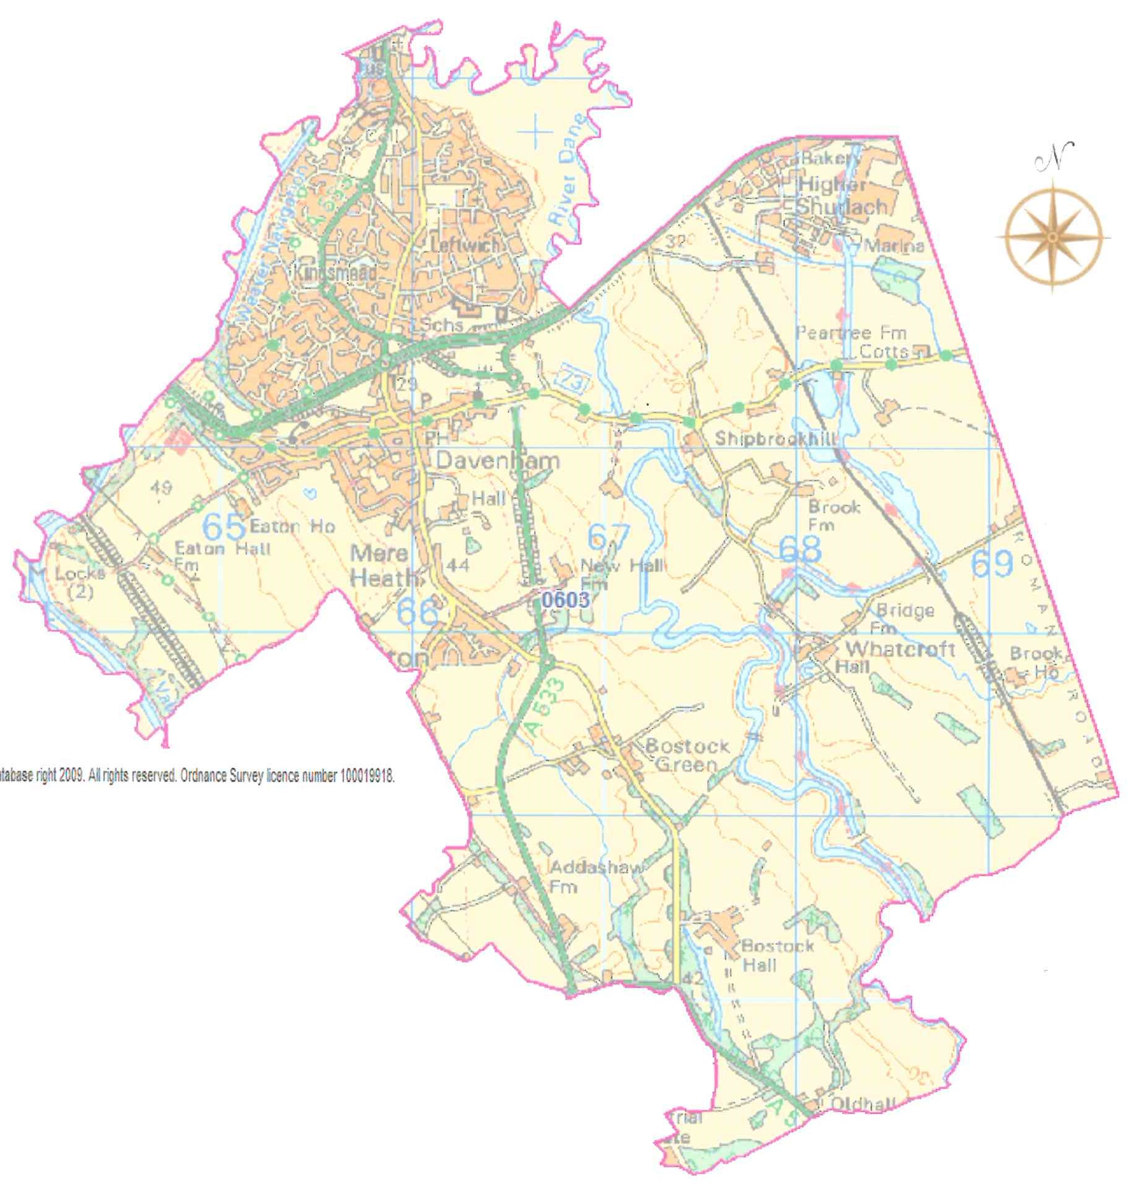
- The Ecclesiastical Parish

The Parish of Davenham (St Wilfrid’s), Leftwich, Kingsmead and Gadbrook is situated in mid Cheshire, in the centre of the diocese. It is a large parish, stretching five miles from north to south, and five miles from east to west. To the north, the parish extends to the railway viaduct across London Road. The western boundary is the River Weaver from the Viaduct Bridge to the Vale Royal Locks. The southern and eastern areas of the parish are almost entirely rural and farming land. The eastern boundary is King Street (old Roman Road) and Bostock Hall lies almost on the southern boundary. Davenham Village lies at the centre of the parish. A map of the parish boundaries is shown above and extends beyond the Admission Priority area.

Address of pupil

The address used on the school’s admission form must be the current one at the time of application. If the address changes subsequently, the parents should notify the school. Where the parents live at different addresses, the current-at-the-time-of-application, normal address of the child will be the one used. This will normally be the one where the child wakes up for the majority of Monday to Friday mornings. Parents may be asked to show evidence of the claim that is being made for the address, e.g. utility bills of various sorts showing the child’s address as the one claimed. Where there is dispute about the correct address to use, the governors reserve the right to make enquiries of any relevant third parties, e.g. the child’s GP. For children of UK Service personnel and other Crown Servants returning to the area proof of the posting is all that is required.

Children with an EHCP

Section 324 of the Education Act 1996 requires the Governing Bodies of all maintained schools to admit a child with an Education Health and Care Plan.

Admission Exceptions

Children of multiple births

In relation to children of multiple births, exceptionally it may be necessary to offer places over the published admission number. This is to ensure that, as far as possible, siblings (twins, triplets or children from other multiple births) can attend the same school.

Children of UK Service Personnel

Places will be allocated in advance of the family arriving in the area for children of UK service personnel and veterans, if accompanied by an official government letter which declares a relocation date and a Unit postal address or quartering area address for considering the application against Davenham C of E School’s oversubscription criteria. In addition the School Admissions Code (December 2014) allows the admittance of a forces child as a permitted exception in relation to infant class size legislation.

Late applications for Reception admission

Where there are extenuating circumstances for an application being received after the last date for applications, and it is before the governors have established their list of pupils to be admitted, then it will be considered alongside all the others.

Otherwise, applications that are received after the last date will be considered after all the others, and placed on the waiting list in order according to the criteria.

Normal Admission Round and Waiting list

Where there are more applications than places during the normal admission round to Reception, the Admissions criteria will be used. Children who are not admitted will have their name placed on a waiting list. The names on this waiting list will be in the order resulting from the application of the admissions criteria. Since the date of application cannot be a criterion for the order of names on the waiting list, late applicants for the school will be slotted into the order according to the extent to which they meet the criteria. It is possible that a child who moves into the area later may have a higher priority than one who has been on the waiting list for some time. If a place becomes available within the admission number, the child whose name is at the top of the list will be offered a place. This is not dependent on whether an appeal has been submitted.

This waiting list will operate until 31st December 2023.

Non-routine admissions: In year applications

For children who move into an area or who move schools outside of the normal admissions round, the in year application process applies.

Parents should contact school in the first instance to enquire about available places in the appropriate year and visit accordingly. If a place is available, application should be made via the Cheshire West Admissions in year application website. The school will arrange for admission and inform the local authority. Any oversubscription will result in the Admission criteria being applied to rank the applications.

Where a place is not available, the application will be declined and information about how to appeal against the refusal will be provided. The pupil will automatically be added to the in year “waiting list” formally known as the Expression of Interest list.

Please note that you cannot re-apply for a place at a school within the same school year unless there has been relevant, significant and material change in the family circumstances.

Appeals

Where the Governors are unable to offer a place because the school is oversubscribed, parents have the right to appeal to an independent admission appeal panel, set up under the School Standards and Framework Act, 1998, as amended by the Education Act, 2002. Parents should notify the Chair of Governors at the school within 20 days of receiving the letter refusing a place. Parents will have the opportunity to submit their case to the panel in writing and also to attend in order to present their case. You will normally receive 14 days’ notice of the place and time of the hearing.

If your child was refused a place in Reception or Key Stage 1 because of Government limits on Infant class sizes, the grounds on which your appeal could be successful are limited. You would have to show that the decision was one which in the circumstances no reasonable governing body would have made, or that your child would have been offered a place if the governors’ admissions arrangements had been properly implemented.
Please note that this right of appeal against the governors’ decision does not prevent you from making an appeal in respect of any other school.

Fraudulent applications

Where the Governing Body discovers that a child has been awarded a place as the result of an intentionally misleading application from a parent (for example a false claim to residence in the catchment area or of involvement in a place of worship) which effectively denies a place to a child with a stronger claim, then the governing body is required to withdraw the offer of the place. The application will be considered afresh and a right of appeal offered if a place is refused.

Deferred admission

If your child is due to start school during the next academic year, it is important that you apply for a place for September. If your child’s fifth birthday is between the months of September and December, then, if you wish it, admission may be deferred until January; if it is between January and April, then admission may be deferred until the start of the summer term though it is likely to be in your child’s interest to start no later than January.

Summer Born Children

Parents of summer born children (those born between 1st April and 31st August) who wish to delay entry until the following year must speak to the school and Local Authority as soon as possible as this would involve either an in-year application for year 1 or a new application for reception in the following year. An application form should be filled in for the current admission process at the same time as any request to defer entry or ‘back class’ to reception in the following year. The decision will be made taking into account information from the parents and headteacher and should be in the best interests of the child.

Parents will be informed of the outcome before primary national offer day.
If the request is agreed, the application for the normal age group may be withdrawn before a place is offered. If the request is refused, the parent must decide whether to accept the offer of a place for the normal age group, or to refuse it and make an in year application for admission to year one for the September following the child’s fifth birthday.

Parents should be aware that agreement by the school to allow a child to enter reception the following year does not guarantee a place in the class. Parents must apply to the school again the following year and the application will be considered in the normal manner following the oversubscription criteria.

EQUALITY STATEMENT

Davenham Primary School is committed to ensuring equality of opportunity for all children, staff, parents, carers and visitors irrespective of their race, gender, gender identity, disability, religion or belief, sexual orientation, marital status, age or pregnancy and maternity. We tackle discrimination through the positive promotion of equality, by valuing diversity, challenging bullying and stereotypes and by creating an inclusive environment which champions fairness and respect for all.

Davenham Church of England Primary School

“Working Together, Playing Together, Serving God and Serving Others”

POLICY FOR ADMISSION 2023 – 2024

Effective Date |  | 24 January 2022
Review Date |  | January 2023
Person Responsible |  | Joanne Hyslop
Signed Headteacher | Signed Chair of Governors |  | Date Ratified
J Hyslop | D Mercer |  | 24 January 2022

