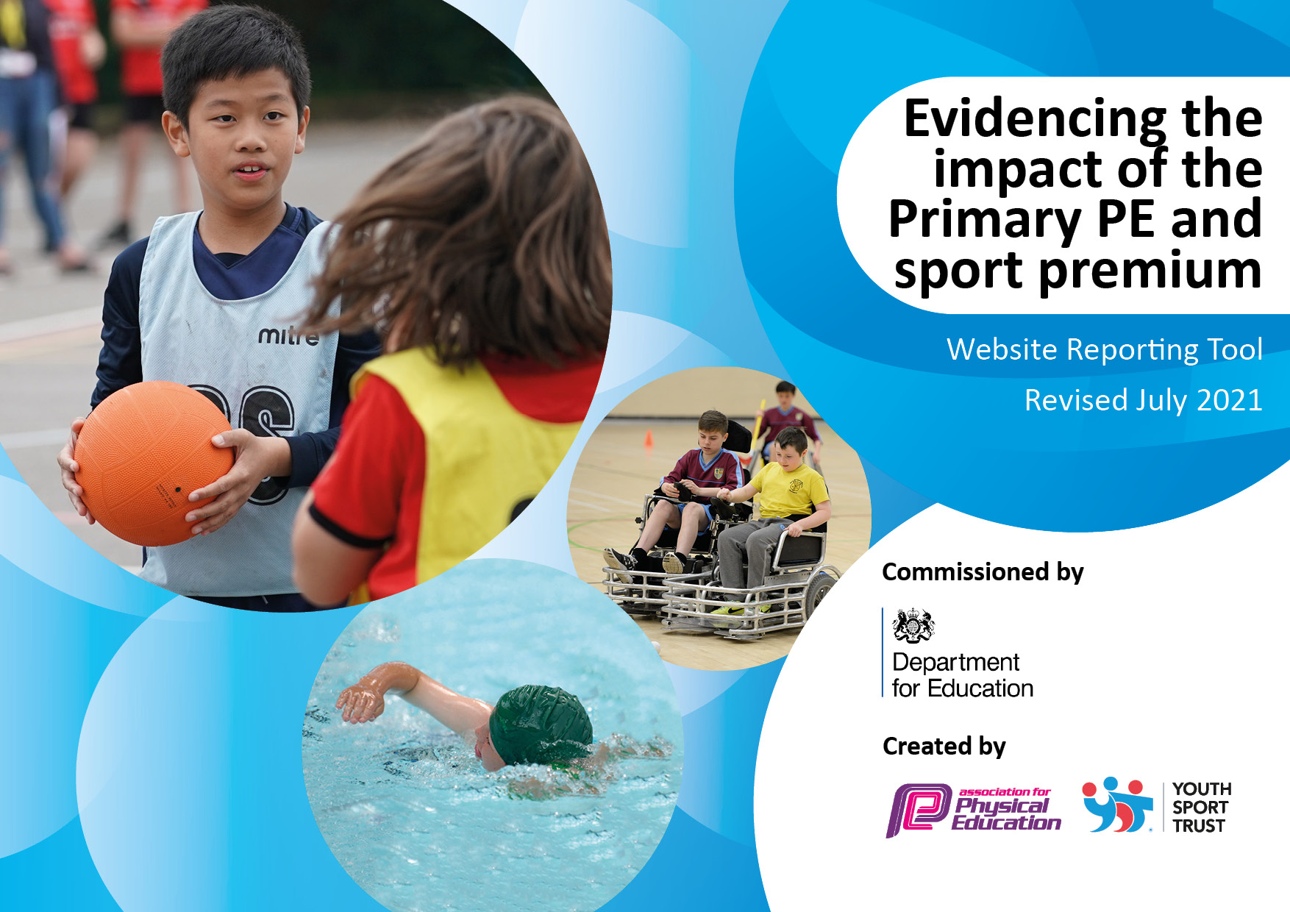

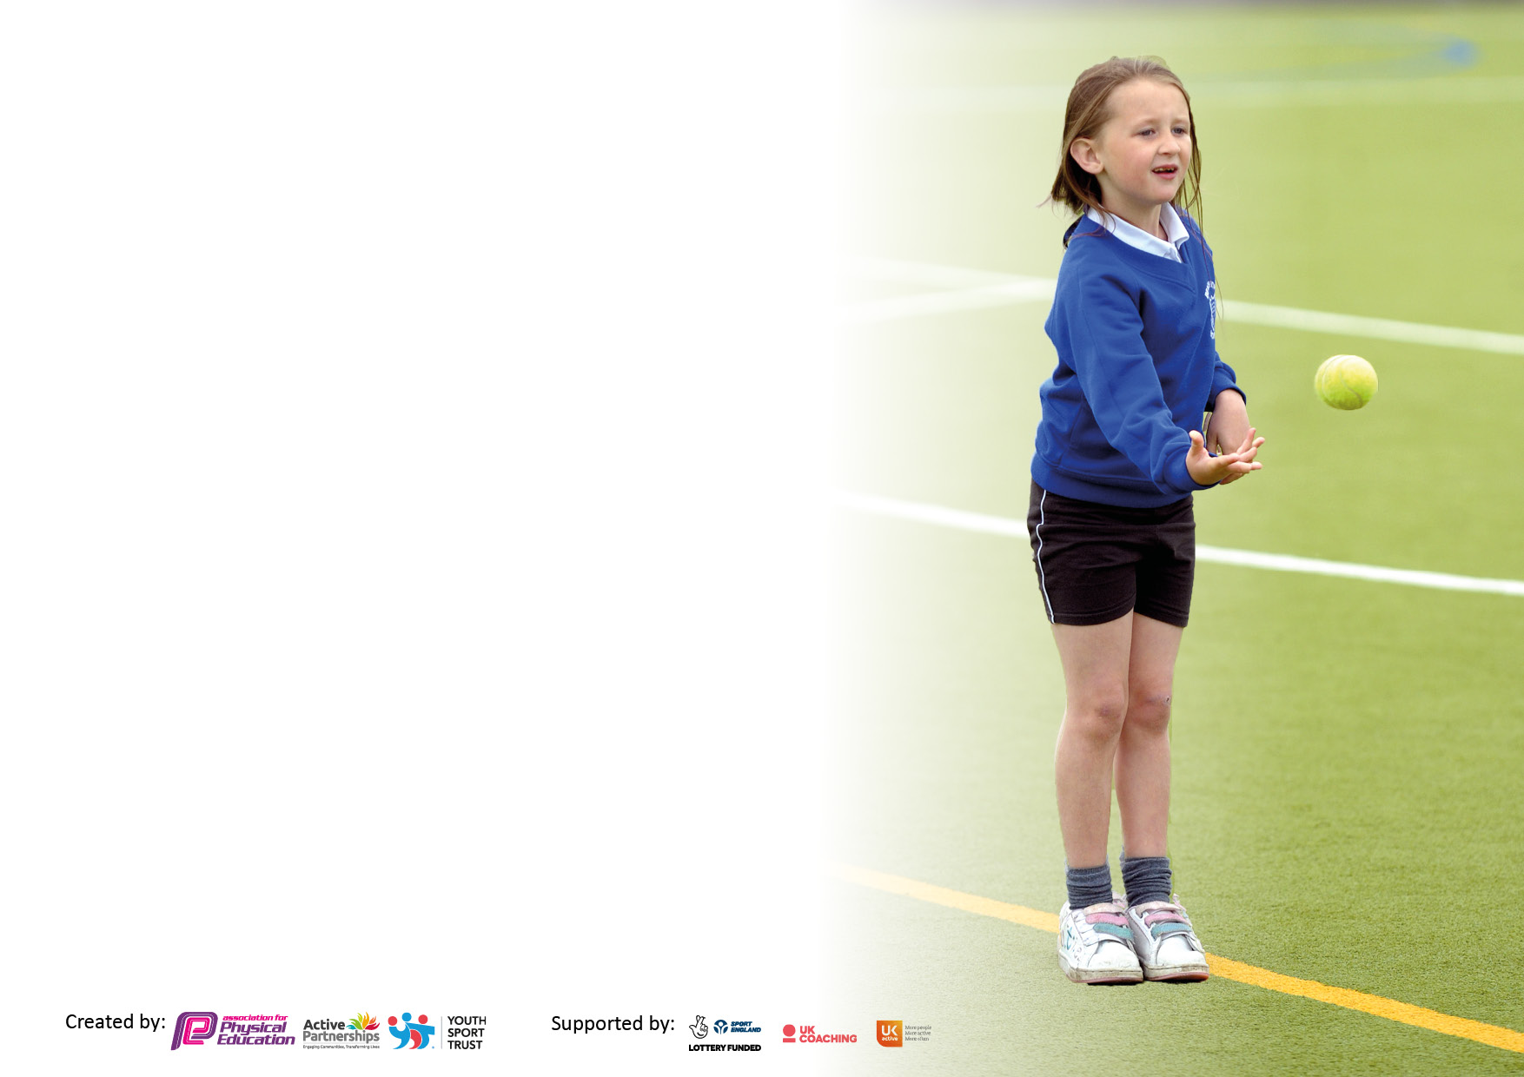

It is important that your grant is used effectively and based on school need. The Education Inspection Framework makes clear there will be a focus on **‘whether leaders and those responsible for governors all understand their respective roles and perform these in a way that enhances the effectiveness of the school’**.

Under the Quality of Education Ofsted inspectors consider:

**Intent** - Curriculum design, coverage and appropriateness

**Implementation** - Curriculum delivery, Teaching (pedagogy) and Assessment

**Impact** - Attainment and progress

To assist schools with common transferable language this template has been developed to utilise the same three headings which should make your plans easily transferable between working documents.

Schools must use the funding to make **additional and sustainable** improvements to the quality of Physical Education, School Sport and Physical Activity (PESSPA) they offer. This means that you should use the Primary PE and sport premium to:

* Develop or add to the PESSPA activities that your school already offer
* Build capacity and capability within the school to ensure that improvements made now will benefit pupils joining the school in future years
* The Primary PE and sport premium should not be used to fund capital spend projects; the school’s budget should fund these.

Pleasevisitgov.ukfortherevisedDfEguidanceincludingthe5keyindicatorsacrosswhichschoolsshoulddemonstrate animprovement.Thisdocumentwillhelpyoutoreviewyourprovisionandtoreportyourspend.DfEencouragesschools to use this template as an effective way of meeting the reporting requirements of the Primary PE and sport premium.

We recommend you start by reflecting on the impact of current provision and reviewing the previous spend.

Schools are required to publish details of how they spend this funding, including any under-spend from 2019/2020, as well as on the impact it has on pupils’ PE and sport participation and attainment. **All funding must be spent by 31st July 2022.**

We recommend regularly updating the table and publishing it on your website throughout the year. This evidences your ongoing self-evaluation of how you are using the funding to secure maximum, sustainable impact. Final copy must be posted on your website by the end of the academic year and no later than the 31st July 2021. To see an example of how to complete the table please click HERE.

Created by: Supported by:

**Details with regard to funding**

Please complete the table below.

|  |  |
| --- | --- |
| Total amount of funding for 2023/24. To be spent and reported on by 31st July 2024. | **£18,790 PE and Sports Premium Grant** |

**Swimming Data**

Please report on your Swimming Data below.

|  |  |
| --- | --- |
| Meeting national curriculum requirements for swimming and water safety.  N.B. Complete this section to your best ability. For example you might have practised safe self-rescue techniques on dry land which you can then transfer to the pool when school swimming restarts.  **Due to exceptional circumstances priority should be given to ensuring that pupils can perform safe self rescue even if they do not fully meet the first two requirements of the NC programme of study** | Year 5 and 6 were provided with swimming instruction as a top up. All pupils were assessed.  A heated pool was hired on site at school for 3 weeks along with swimming instructors for this purpose.  Year 3 pupils completed swimming lessons at the local pool. |
| What percentage of your current Year 6 cohort swim competently, confidently and proficiently over a distance of at least 25 metres?  **N.B.** Even though your pupils may swim in another year please report on their attainment on leaving primary school at the end of the summer term 2024.  Please see note above | 100 % |
| What percentage of your current Year 6 cohort use a range of strokes effectively [for example, front crawl, backstroke and breaststroke]?  Please see note above | 88% |
| **What percentage of your current Year 6 cohort perform safe self-rescue in different water-based situations?** | 100% |
| Schools can choose to use the Primary PE and sport premium to provide additional provision for swimming but this must be for activity **over and above** the national curriculum requirements. Have you used it in this way? | Yes – see above comment and costings in KI 4 |

**Action Plan and Budget Tracking**

Capture your intended annual spend against the 5 key indicators. Clarify the success criteria and evidence of impact that you intend to measure to evaluate for pupils today and for the future.

|  |  |  |  |  |
| --- | --- | --- | --- | --- |
| **Academic Year:** 2023/24 | **Total fund allocated: £18,790** | **Date Updated: 25/07/2024** | |  |
| **Key indicator 1:** The engagement of all pupils in regular physical activity – Chief Medical Officers guidelines recommend that primary school pupils undertake at least 30 minutes of physical activity a day in school | | | | Percentage of total allocation: |
|  |
| **Intent** | **Implementation** | | **Impact** |  |
| Your school focus should be clear what you want the pupils to know and be able to do and about  what they need to learn and to  consolidate through practice: | Make sure your actions to achieve are linked to your intentions: | Funding allocated: **£25,207** | Evidence of impact: what do pupils now know and what can they now do? What has changed? | Sustainability and suggested next steps: |
| To look at a professional company delivering Forest Schools to children | Footprints in the Sand Forest schools provider to deliver outdoor activities for all classes 3 times a year | **£1950** | Pupils learned how to stay safe in forest school environment. Learned how to make a fire safely and make basic tools. | Consider use of PP budget for this next year |
| For the children to be engaged in regular and varied physical activity (including after school competitions) and to understand why physical activity is important | VRSS Partnership to provide a range of activities for children to engage with, including cricket and baton relay with other local schools.  Sports Apprentice to provide physical activity during morning session before school started. | **£3647** (Vale Royal Sports Partnership and School Sports Services)  **£2540** (Sports Apprentice) | Children have further developed their understanding of the importance of regular physical activities  Sports Apprentice has continued to raise the profile of physical activity during the school day | PE lead to look at all areas of PE next year – employed each afternoon to lead PE |
| To use Sports Coaches to provide lunchtime clubs to increase physical activity at lunchtime | Sports coaches to deliver lunch time sports activities |  | Children have developed an awareness of a wider range of activities – e.g. archery | PE lead to look at lunchtime activities this next year |
| To use Sports Coaches to deliver PE in school | Sports coaches to deliver afternoon PE sessions for most classes | £10,520 | Children have developed an awareness of a wider range of activities – e.g. archery  Children have had access to PE lessons delivered by experts in the field | PE lead to look at clubs this next year |
| Project Touchline | Linked to our work on Christian Values, Project Touchline will use PE as a vehicle to help pupils understand how to live out our Christian values | £4180 | Children better understand how Christian values can be lived out through sport. Access to Tag Rugby as a sport. | Consider Project Touchline next year |
| **Key indicator 2:** The profile of PESSPA being raised across the school as a tool for whole school improvement | | | | Percentage of total allocation: |
| **18.39%** |
| **Intent** | **Implementation** | | **Impact** |  |
| Your school focus should be clear what you want the pupils to know and be able to do and about  what they need to learn and to  consolidate through practice: | Make sure your actions to achieve are linked to your intentions: | Funding allocated:  **£3455** | Evidence of impact: what do pupils now know and what can they now do? What has changed? | Sustainability and suggested next steps: |
| Consider using sports coaches to provide clubs after school so that a greater range of clubs can be offered including those for younger children | A wide variety of clubs to be offered during the course of the year some at nil cost. | **£3455** | Pupils accessed a wider range of clubs  Parental feedback was extremely positive  Pupil feedback was extremely positive | PE Lead staff to look at clubs this year |
| To have a whole school focus on developing a wider range of clubs for the children in the next academic year, including younger children | A wide variety of clubs to be offered during the course of the year some at nil cost. | **£3455** | KS1 Pupils accessed a wider range of clubs  Parental feedback was extremely positive  Pupil feedback was extremely positive | PE Lead to look at clubs this year |
| Engage parents to help with coaching – football and netball. | Parents to support netball club |  | This did not happen due to lack of volunteers | Look again at volunteers |
| Sports Apprentice to offer clubs after school | Sports Apprentice to offer clubs |  | Pupils accessed a wider range of clubs  Parental feedback was extremely positive  Pupil feedback was extremely positive | Apprentice no longer employed by school. PE lead to look at clubs this year |
| Sports coaches provided after school clubs paid for by parents.  Develop a girl’s football team | Sports coaches to offer a range of clubs to different ages  PE lead developed a girls football team and attended 4 local and district competitions. An exclusive lunch time club was offered to all KS2 girls to play football within school | Nil to school      Nil to school | Surveys show that parents appreciate the clubs that have been offered  Pupils benefitted from coaching  Huge increase in girls participation in football. KS2 girls were signposted and joined clubs outside of school. Girls team won 2 tournaments and multiple fixtures across the year. | Sports Coaches are no longer employed by school. Member of staff to look at clubs this year  Look at bringing in some female role models to talk to the children about wider opportunities in sport. Continue to develop the girls teams and attend all girls only competitions across the academic year. |

|  |  |  |  |  |
| --- | --- | --- | --- | --- |
| **Key indicator 3:** Increased confidence, knowledge and skills of all staff in teaching PE and sport | | | | Percentage of total allocation: |
| **35.76%** |
| **Intent** | **Implementation** | | **Impact** |  |
| Your school focus should be clear | Make sure your actions to | Funding | Evidence of impact: what do | Sustainability and suggested |
| what you want the pupils to know | achieve are linked to your | allocated: | pupils now know and what | next steps: |
| and be able to do and about | intentions: | **£6720** | can they now do? What has |  |
| what they need to learn and to |  |  | changed? |  |
| consolidate through practice: |  |  |  |  |
| Sports Coaches to be used to deliver PE lesson (teachers to be present for CPD | Sports Coaches to organise PE timetable so that as many staff as possible benefit from CPD | **£4180** | Staff report increased confidence | Employ our own member of staff to carry out CPD next year |
| Sports apprentice provided clubs to enhance provision and CPD of staff | Apprentice to organise a timetable of clubs | **£2540** | Pupils accessed a wider range of clubs  Positive feedback from parents and pupils | Apprentice has left school to complete teacher training |
| **Key indicator 4:** Broader experience of a range of sports and activities offered to all pupils | | | | Percentage of total allocation: |
| **27.14%** |
| **Intent** | **Implementation** | | **Impact** |  |
| Your school focus should be clear | Make sure your actions to | Funding | Evidence of impact: what do | Sustainability and suggested |
| what you want the pupils to know | achieve are linked to your | allocated: **£5100** | pupils now know and what | next steps: |
| and be able to do and about | intentions: |  | can they now do? What has |  |
| what they need to learn and to |  |  | changed?: |  |
| consolidate through practice: |  |  |  |  |
| To provide small group swimming lessons to Year 5 and 6 | A heated, pop up pool to be provided on site for 3 weeks with instructors | **£5100** | Children report enjoying lessons and those children who lacked confidence reported that the on-site pool, the small groups and the instructors really helped them to gain water confidence  Parent feedback via Parent Council and Parent surveys was excellent. | Consider using pool again after reviewing costs  May need financial support from FODS due to budget constraints |
| Year 6 children to take part in a community event – Crown Green Bowling. | Organise for Y6 pupils to visit bowling green with site manager who plays crown green bowls | **£0** | Children enjoyed playing with members of the community at the local bowling club. | Repeat bowling experience on an annual basis. |

|  |  |  |  |  |
| --- | --- | --- | --- | --- |
| **Key indicator 5:** Increased participation in competitive sport | | | | Percentage of total allocation: |
| **2.66%** |
| **Intent** | **Implementation** | | **Impact** |  |
| Your school focus should be clear | Make sure your actions to | Funding | Evidence of impact: what do | Sustainability and suggested |
| what you want the pupils to know | achieve are linked to your | allocated: | pupils now know and what | next steps: |
| and be able to do and about | intentions: | **£500** | can they now do? What has |  |
| what they need to learn and to |  |  | changed?: |  |
| consolidate through practice: |  |  |  |  |
| To further develop participation in competitive sport in the next academic year by using the Sports Apprentice to accompany children to events | The sports apprentice will be used to accompany children to sports competitions | **£500** | More children were able to access competitive sports | Continue to develop participation in competitive sports. Look at refining selection process to engage more children  Develop more teams and take part in more competitions, including a girls football team |
| To further develop community links | Community groups approached school and it was agreed that the school field could be used | **£0** | Strengthened links with community clubs  Community clubs have a base from which to train / hold fixtures | Maintain community links |

|  |  |
| --- | --- |
| Signed off by | |
| Head Teacher: | Joanne Hyslop |
| Date: | 25 July 2024 |
| Subject Leader: | Tyler Roberts |
| Date: | 25 July 2024 |
| Governor: | Martin Mewies |
| Date: | 25 July 2024 |