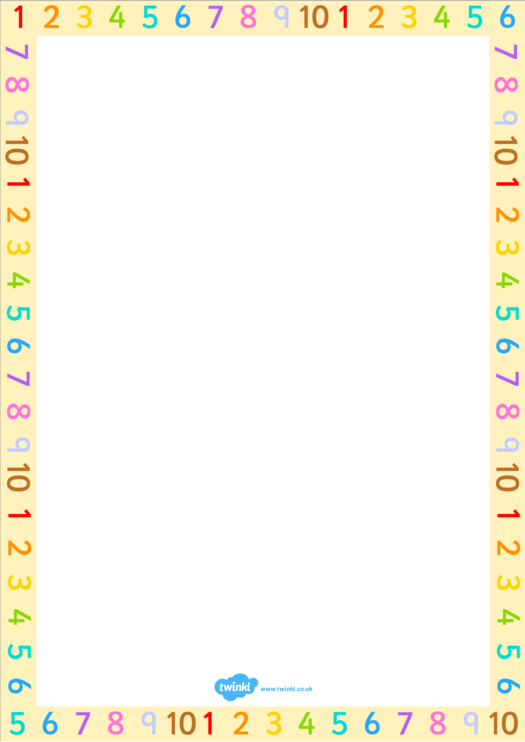


15.9.17
LO: I can form numbers correctly.
Today I am number detective
Numbers with straight
lines

Both

Numbers with curvy lines

