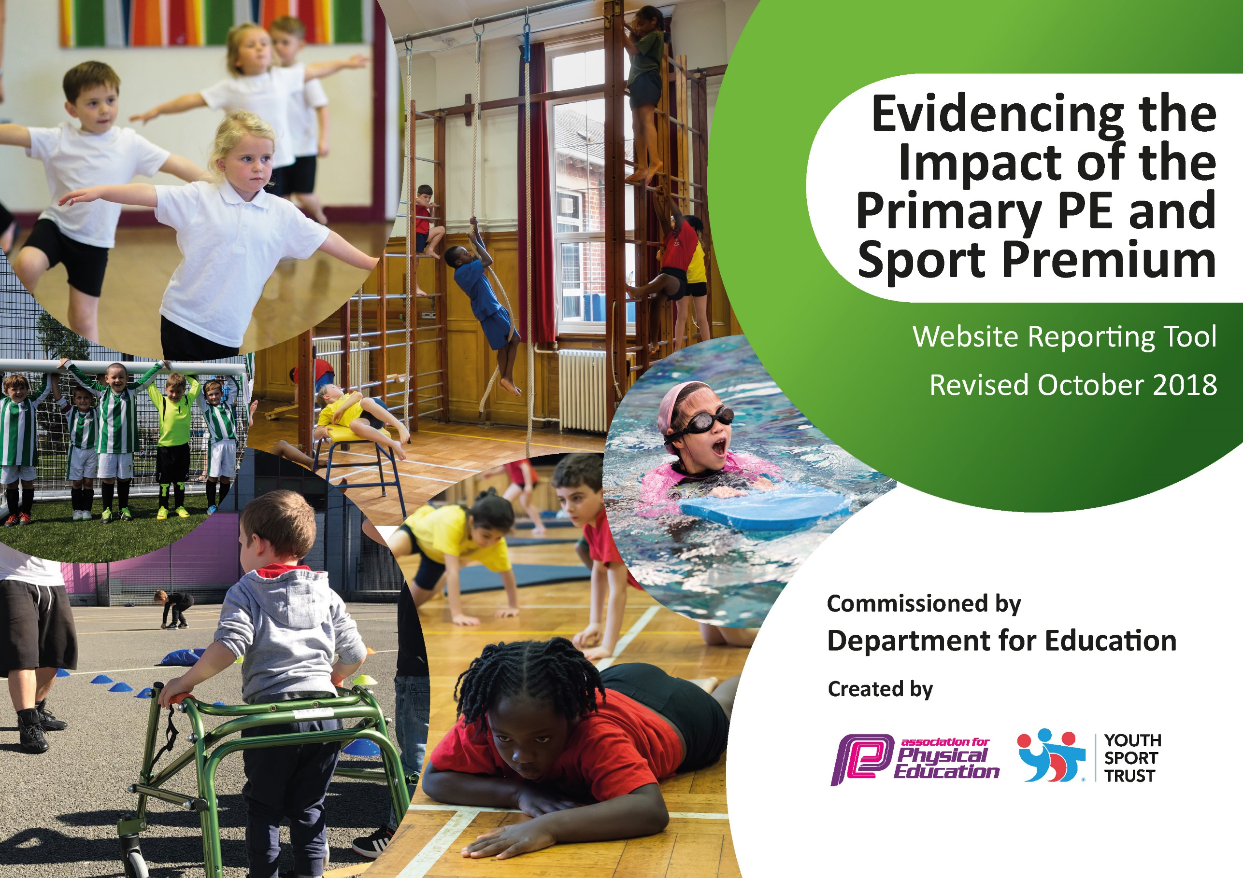
Support for review and reflection - considering the 5 key indicators from DfE, what development needs are a priority for your setting and your students now and why? Use the space below to reflect on previous spend, identify current need and priorities for the future.

Key achievements to date: | Areas for further improvement and baseline evidence of need:
- Providing 2 hours of PE per week for all pupils  - Upskilling staff in PE  - Celebration of sporting achievements (Notice board, Family service, website, Newsletter)  - Introduction of Active Breakfast clubs  - Provide a wider range of Active After-school clubs  - More pupils to experience Representing the school at Sporting Fixtures  - Staff to continue to work alongside & plan with PE Mentor  - Reward pupils for outstanding Sporting Values | - Sporting Challenges to increase engagement of physical activity during the day  - Develop a wider range of activities during active breaks and lunchtimes whilst maintaining COVID-19 guidance.  - Develop Daily Mile by introducing different physical activities during the Scenic Stomp (skipping rope, catching, physical exercise zones)  - Promote sporting inspirations within school  - Continued CPD training for staff on specific sporting areas. Questionnaire to be sent out.

Meeting national curriculum requirements for swimming and water safety | Please complete all of the below:
What percentage of your current Year 6 cohort swim competently, confidently and proficiently over a distance of at least 25 metres?  N.B. Even though your children may swim in another year please report on their attainment on leaving  primary school. | Approx. 83%  Top up cancelled due to COVID-19
What percentage of your current Year 6 cohort use a range of strokes effectively [for example, front crawl, backstroke and breaststroke]? | Approx. 83%
What percentage of your current Year 6 cohort perform safe self-rescue in different water-based situations? | Sessions cancelled due to COVID-19
Schools can choose to use the Primary PE and Sport Premium to provide additional provision for swimming but this must be for activity over and above the national curriculum requirements. Have you used it in this way? | No  COVID-19

Action Plan and Budget Tracking
Capture your intended annual spend against the 5 key indicators. Clarify the success criteria and evidence of impact that you intend to measure to evaluate for students today and for the future.

Academic Year: 2019/20 | Total fund allocated: £18730  b/f overspend £1563  2019/20 spend £17018  Total spend £18581  c/f underspend £149 |  |  | Date Updated: July 2020
Key indicator 1: The engagement of all pupils in regular physical activity – Chief Medical Officer guidelines recommend that primary school children undertake at least 30 minutes of physical activity a day in school |  |  |  |  |  |  |  | Percentage of total allocation:
 |  |  |  |  |  |  |  | %
School focus with clarity on intended impact on pupils: | Actions to achieve: |  |  | Funding allocated: |  |  | Evidence and impact: | Sustainability and suggested next steps:
- Equipment to be more accessible to children.  - Quality of equipment to be maintained through storage.  - Wider opportunities to involve all children in School Sport.  - For EYFS children to have greater opportunity to explore physical activity during outdoor learning time. | - New equipment purchased (shed)  - Registration with VRSSP** -providing BB training, 5-a-day registration  - Break-time Buddies training provided by VRSSP**  - Line markings for active playtimes  - Physical Play equipment EYFS |  |  | £863  £2766 **  £3462 |  |  | - Equipment is now more easily accessible and therefore children are more active and enthusiastic during break times.  - A wider variety of events are now available which has given us the opportunity to get more children involved in sport including our vulnerable/SEN children.  - EYFS pupils are now more engaged in outdoor physical activities. Evidence through Online Learning Platforms | - Develop a wider range of activities during active breaks and lunchtimes whilst maintaining COVID-19 guidance.  - Develop Daily Mile by introducing different physical activities during the Scenic Stomp (skipping rope, catching, physical exercise zones)
Key indicator 2: The profile of PESSPA being raised across the school as a tool for whole school improvement |  |  |  |  |  |  |  | Percentage of total allocation:
 |  |  |  |  |  |  |  | %
School focus with clarity on intended impact on pupils: | Actions to achieve: |  |  | Funding allocated: |  | Evidence and impact: |  | Sustainability and suggested next steps:
- Continue to increase the number of pupils attending sporting fixtures and events, giving pupils the opportunity to try new sports.  - To encourage more children to take part in breakfast & afterschool sporting clubs with qualified coaches. | - To give pupils the opportunity to experience a wide variety of sports through VRSSP competitions and Extra curricular clubs  SSS  Midas training for MO.  - Employment of Qualified Coaches to deliver specific extra-curricular clubs. |  |  | £631.20  £160  £300 |  | A (competitive), B & C teams (non-competitive) taken to a wide variety of Autumn & Winter sports.  Transport issues to events were eased.  Pupils completed a questionnaire on current sporting activities outside of school and wish list of school based Extra Curricular clubs. Clubs were then set up based on these wishes and the uptake was evaluated by Ofsted. |  | - Sporting Challenges to increase engagement of physical activity during the day  - Promote sporting inspirations within school
Key indicator 3: Increased confidence, knowledge and skills of all staff in teaching PE and sport |  |  |  |  |  |  |  |  | Percentage of total allocation:
 |  |  |  |  |  |  |  |  | %
School focus with clarity on intended  impact on pupils: |  | Actions to achieve: | Funding  allocated: |  | Evidence and impact: |  |  |  | Sustainability and suggested  next steps:
- To employ a PE student to assist staff with the delivery of PE.  - PE lessons to be more engaging for pupils with the inclusion of a variety of equipment. |  | - PE Apprentice to attend Sporting Futures.  - New PE equipment purchased for the use during PE lessons and to help staff to deliver more engaging lessons. | Salary and training and insurance totalled £8390  £446 |  | - Staff were more confident having an apprentice working alongside them, also providing resources and equipment to enable them to deliver their lessons.  - In depth lessons were delivered e.g. gymnastics using the lesson plans and equipment provided. Staff were therefore more confident in delivering the content. |  |  |  | - Continued CPD training for staff on specific sporting areas. Questionnaire to be sent out.
Key indicator 4: Broader experience of a range of sports and activities offered to all pupils |  |  |  |  |  |  |  |  | Percentage of total allocation:
 |  |  |  |  |  |  |  |  | %
School focus with clarity on intended  impact on pupils: |  | Actions to achieve: | Funding  allocated: |  | Evidence and impact: |  |  |  | Sustainability and suggested  next steps:
Additional achievements:  - Extra training sessions for sports teams prior to events.  - Additional sporting opportunities booked throughout the year. |  | - Employment of Qualified Coaches to deliver specific extra-curricular clubs.  - Via VRSSP and outside sports coaches (Chance to Shine). | As indicators 1 & 2 |  | - More teams were successful in getting through to the next stage of competitions.  - Limited due to COVID-19. We were able to secure wheelchairs for wheelchair basketball. |  |  |  | - Continue to look for new areas of development in PE to engage our pupils.
Key indicator 5: Increased participation in competitive sport |  |  |  |  |  |  |  |  | Percentage of total allocation:
 |  |  |  |  |  |  |  |  | %
School focus with clarity on intended  impact on pupils: |  | Actions to achieve: | Funding  allocated: |  | Evidence and impact: |  |  |  | Sustainability and suggested  next steps:
Additional achievements:  - Extra training sessions for sports teams prior to events.  - Additional sporting opportunities booked throughout the year. |  | - Employment of Qualified Coaches to deliver specific extra-curricular clubs.  - Via VRSSP and outside sports coaches (Chance to Shine). | As indicators 1 & 2 |  | - More teams were successful in getting through to the next stage of competitions.  - Limited due to COVID-19. We were able to secure wheelchairs for wheelchair basketball. |  |  |  | - To secure a minibus for sports week to enable as many children as possible to take part.

