DAVENHAM C OF E PRIMARY SCHOOL
Charles Avenue, Davenham, Northwich, Cheshire, CW9 8JW
Telephone 01606 42551
Mobile (for emergencies) * 07985 725859
www.davenhamcofeprimary.com
@davenhamcofe

WEEKLY NEWSLETTER

3rd January 2024

'Do not let your hearts be troubled.
Trust in God; trust also in me.'
John 14:1

The format of the Newsletter is as follows:

Section 1 | Individual Class Dates for the following week. Any actions you need to take will be in red font.  Whole school events for the following week.  FODS and Parent Council dates for this half term.
Section 2 | News Items (general school information)
Section 3 | Other News – parents are welcome to contribute to this section. Please send any items to Mrs Hyslop
Section 4 | Standing Items (always in blue font)  Useful reference information.

THANK YOU!
Thank you for all the lovely Christmas messages, cards and gifts that were received over the festive period. We hope that you all had a lovely Christmas break and wish you all a very happy and prosperous New Year!

SECTION 1 DATES
TABLE 1 CLASS EVENTS
8th – 12th Jan

Class | Activity | Date
Oaks and Jack
Eaton Y1
Firthfields Y1 and 2
Fountain Y2
Pavilions Y3
Mere Y3 and 4
Mount Pleasant Y4
Green Y5
Charles Y5
Hartford Y6
London Y6 | Come Join Us 2.15pm – 2.45pm  Family Service 2.45pm | Fri 12th

COME JOIN US AND FAMILY SERVICE
Please note new times and format for Come Join Us and Family Service.
Please use the main door to enter school.

OUTDOOR LEARNING
Please note that Outdoor Learning sessions will now be delivered by a specialist company and will focus on skills such as den building, making tools etc. As such children DO need to wear old clothes and bring a change of shoes / wellingtons. Thank you

TABLE 2
WHOLE SCHOOL EVENTS NEXT WEEK 8th – 12th January 2024

Monday | KS1 Wonderdome (all y1 and Y2 children)
Tuesday
Wednesday
Thursday | Young Voices Concert (letters have already been sent out)
Friday

TABLE 3
FODS AND PARENTS COUNCIL MEETINGS

FODS | 8 January
PARENT COUNCIL | 9 January

SECTION 2 NEWS

NEW CHRISTIAN VALUE
Our new Christian Value for this half term is Trust.
God is amazingly loving and powerful.
We can trust him to be kind and get things done.
When we have worries and cares we can go to God with them who is always there for us.
Our story for Trust is Jesus walks on water.

VALE ROYAL SCHOOL PARTNERSHIPS
AFTER SCHOOL SPORTS EVENTS AND COMPETITIONS

CELEBRATE | These events are for children who don’t attend sporting activities or have additional needs and would benefit from taking part in an event.
ASPIRE | These events are for children developing sporting skills in a semi-competitive environment. These events are for children who may not necessarily be involved in a community club.
INSPIRE | These are competitive events and lead to finals. They are aimed at children who are highly competitive and comfortable with challenge.

Details are on Google Classroom. Please register interest via the survey on the Website. Please send any queries about the event to Mr Roberts troberts@davenhamce.cheshire.sch.uk.

CHARITY FUNDRAISING

Detail | Charity | Amount Raised
Hello Yellow | Young Minds | £202.60
Harvest | Mid Cheshire Food Bank | £270.30
Children in Need | Children in Need | £236.53
Remembrance Day | Royal British Legion | £402.82
Christingle | The Children’s Society | £153.30
 |  | £1265.55

FORTHCOMING RESIDENTIAL VISITS AND COSTINGS

Visit, Year Group and Date of Visit | Instalment Date and Amount
Robinwood 2024 | Deposit £10 30 March  Balance £255 10 Jan 2024
Year 6 London 2024  23 – 24 May 2024 | Total Cost £295  £55 by 5 June  £70 by 24th July  Balance £170 by 8th March 2024
Year 2 Tattenhall | Total cost £100

SECTION 3 OTHER NEWS

PLEASE NOTE THAT WE ARE NOT AFFILIATED WITH ANY COMPANIES WHO ASK TO PLACE AN ADVERT IN OUR NEWSLETTER

SOUND TECHNIQUE
There is availability for Guitar and Keyboard lessons. Please call Mel at Sound Technique on 07496042559 for more information.

From Revd Rob:
At St Wilfrid’s, Davenham, we have two Sunday morning services:
We have a classic 9:30am service, and we also have an 11:00am all age service with a difference – it’s modern, with interaction and crafts for younger people and is particularly suitable for families and younger people. All are very welcome.
Please see our Church Website for any updates - davenhamparish.net

PARENT SUPPORT HUB https://www.facebook.com/115801448114488/posts/pfbid02GgkvaSqwpQQZupuoDBibFgiyoZTZU3L9e691rjg5uQc1hH167EeJQSn4BFaddFWHl/?sfnsn=scwspmo

PUPIL PREMIUM INFORMATION FOR SEPTEMBER 2023
Dear Parents and Carers,

We are asking parents and guardians whose children go to school in the Cheshire West and Chester area, have a child in reception, year 1 or year 2 in September 2023 and have an entitlement to free school meals to complete an on-line application for free school meals.
Please go to www.cheshirewestandchester.gov.uk , Schools & Education, then Free School Meals where you can apply on-line. The on-line eligibility checker will notify you straight away if you do or do not qualify. We will start to accept applications for Free School Meals from July 2023, please do not apply before July 2023 as your application may not be accepted.
All pupils in the above year groups will be able to receive a school meal at no cost to the parent/guardian. We need to ensure that all parents/guardians that have a statutory entitlement to a free school meal complete the on-line form. We will then be able to confirm whether the school is entitled to claim the pupil premium for your child.
The Pupil Premium is extra money given to your child’s school to spend on resources such as one to one tutoring, music lessons, extra-curricular clubs and school trips. For 2023/2024 this is £1320 per pupil. Funding is based on children registered for a free school meal, further reinforcing the importance of making sure all those who qualify are registered.
Your child may be entitled to receive free school meals if you are entitled to receive one of the following:
- Income Support
- Income-based Jobseeker’s Allowance
- Income-related Employment and Support Allowance
- Support under Part VI of the Immigration and Asylum Act 1999
- The Guarantee element of State Pension Credit
- Child Tax Credit, provided you are not entitled to Working Tax Credit and have an annual income that does not exceed £16,190.
- Universal Credit (Provided you have an annual net earned income of no more than £7,400)

It is really important that you complete the on-line form to help make sure your child’s school is funded as well as possible. If you cannot apply on-line you can telephone Free School Meals on 0300 123 7039.
Yours sincerely Free School Meals

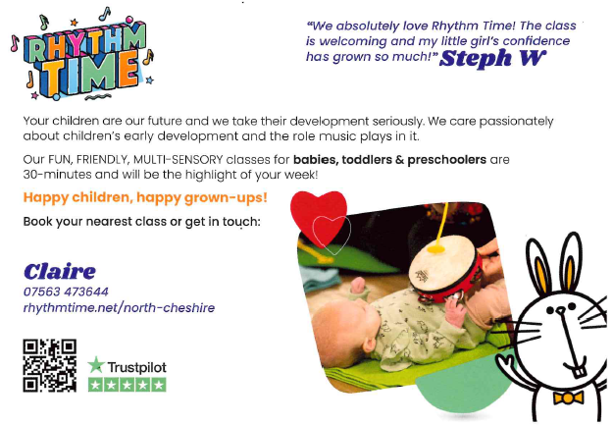

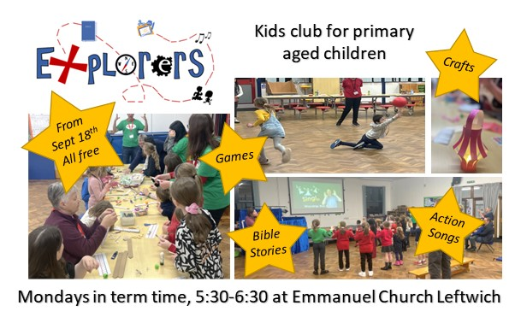

Please remember to ask for the Gardens for Schools Vouchers if you shop at Winnington Garden Centre.

SECTION 4 STANDING ITEMS (appear in blue)

FIXED PENALTY NOTICES
A Fixed Penalty Notice can be issued in cases of unauthorised absences of at least 10 consecutive school sessions (five school days). At Davenham, all requests for holidays in term time will be unauthorised unless in exceptional circumstances. Such circumstances include the wedding of a close family member or the funeral of a close family member.
REPLY SLIPS
All communication is now via email. If parents find it difficult to print out, a reply slip, then please write a return on a slip of paper or come into the school office.

APPLICATIONS FOR CHILDREN STARTING PRIMARY SCHOOL SEPTEMBER 2024
Please take careful note of the following dates. Failure to apply by the closing dates may result in your child not being offered the place you want.

1 Sep 2023 | Application process starts - online application facility open,
15 January 2024 | Closing date for applications forms to be returned to the Council
16 April 2024 | Online applicants can view the school place offered by logging into their online account
16 May 2024 | Closing date for appeal applications

APPLICATIONS FOR CHILDREN STARTING SECONDARY SCHOOL SEPTEMBER 2024

1 Sep 2023 | Application process starts - online application facility open,
31 Oct 2023 | Closing date for applications forms to be returned to the Council
1 March 2024 | Online applicants can view the school place offered by logging into their online account
15 April 2024 | Closing date for appeal applications

FREE SCHOOL MEALS AND PUPIL PREMIUM
Your child may be able to get free school meals if you are in receipt of any of the following:
- Income Support
- Income-based Jobseeker’s Allowance
- Income-related Employment and Support Allowance
- Support under Part VI of the Immigration and Asylum Act 1999
- The guaranteed element of Pension Credit
- Child Tax Credit (provided you’re not also entitled to Working Tax Credit and have an annual gross income of no more than £16,190)
- Working Tax Credit run-on - paid for 4 weeks after you stop qualifying for Working Tax Credit
- Universal Credit - if you apply on or after 1 April 2018 your household income must be less than £7,400 a year (after tax and not including any benefits you get)
The criteria also apply if your child is adopted or under a special guardianship order. Please speak to Mrs Colloby in the school office. It is important that you register, even if your child currently receives Universal Free Infant School Meals as there is additional funding (Pupil Premium) that school can apply for. https://www.gov.uk/apply-free-school-meals

Our School Prayer

Dear Father God
Bless Davenham School
That working together and playing together.
We may learn to serve you and to serve others.
Amen

Remember to …

‘…encourage one another and build each other up…’
1 Thessalonians 5:11.

Items for the Newsletter
If you have any items you would like to put in the Newsletter such as information about local events or clubs, please email me at head@davenhamce.cheshire.sch.uk
As always, should you have any concerns or questions, please come into school. Problems can often be dealt with very quickly- when we know about them!

Mrs J M Hyslop Headteacher

