Governor Biographies
Martin Mewies
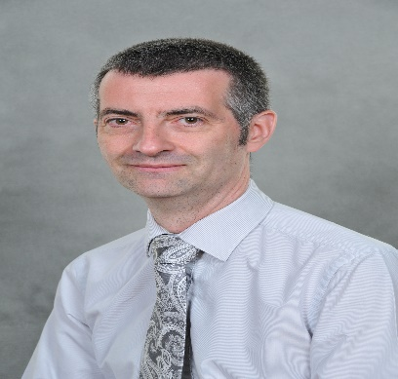
Hello.
I am Martin, and I have been one of the school Governors since 2018 and Chair of Governor since November 2022.I trained as a biochemist and then moved into university research, where I had the opportunity to become involved in teaching students. After that, I spent many years in the pharmaceutical industry, developing new medicines. Now, I work as a consultant in pharmaceutical regulation, helping companies to bring new medicines to market.

When I get a chance, I enjoy fencing, playing cricket and board games, and love doing cryptic crosswords whilst listening to progressive rock music.
My family has been part of St Wilfrid’s Church for fifteen years, and my daughter Nina attended the school from Reception through to Year 6. I strongly believe in giving back to the community, so have been very happy to serve as a foundation Governor and support the Christian ethos of the school. I have been able to use my professional skills to act as Link Governor for Science, as well as for Health and Safety. I am also part of the policy and pay working groups. It has been great to be back supporting education and very rewarding to be able to continue to be part of the School community.

Gareth Peel
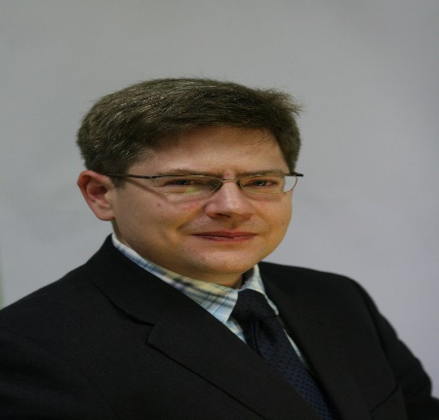
Hi, I am Gareth Peel and I am one of the foundation Governors, and Deputy Chair, serving Davenham CofE Primary School. I have two daughters who benefited from their time at Davenham and are both now at Leftwich High School.
I am a director with Veolia Nuclear Solutions, an international business developing solutions for the processing and disposal of nuclear wastes. I find myself working across different cultures and time zones on a daily basis.
A mechanical engineer by background with a PhD from my time working in robotics at the University of Surrey, I am a keen supporter of science, technology and innovation. My career, which started with the Royal Air Force as a Communications Officer, has focussed on project management and business strategy. Roles in which I have found myself on parade at Westminster Abbey, delivering multi-million-pound projects, and providing strategic advice to the government on civil nuclear issues.
I also support the Institute of Mechanical Engineers. Through this volunteering I am a keen supporter of science, technology, engineering and maths (STEM) but I am equally aware, having written academic papers, articles in the press and plenary speeches, that the power of the written and spoken word to communicate our messages is equally empowering.

Rob Iveson
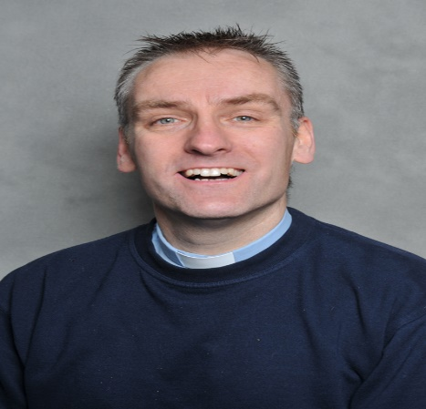

My name is Rob Iveson. I am the Rector of St Wilfrid’s, Davenham. I am on the School Governors automatically because of the role with Davenham Primary being a Church of England Primary School.
I was born and raised in the Wirral. I am married to Alison who is from London. Ali and I have three teenage daughters - Jemma, Nicole and Danielle, and we have two dogs (both girls). I am seriously outnumbered!
I got Ordained in 2001, and then married Alison two months later. We met whilst I was in training in London. I did my curacy in Cheadle and then led a church for almost ten years in Cheadle Hulme – both places are near Stockport. I have been in post at St Wilfrid’s for nearly 9 years.
I enjoy golf, swimming, running and the gym; socialising; watching a good film or comedy show. Liverpool is my team.
My passion is sharing the life changing love of Jesus with the people around me.

Richard Warburton - Co-Opted Governor

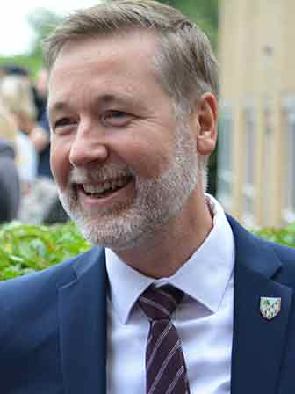

I joined the Governing Body at Davenham CE Primary School in 2021 which has provided an opportunity to serve in the wider community supporting a partner primary. I am a member of the Finance and Staffing Committee.
I am Headteacher of The County High School Leftwich and have been a teacher at CHSL for over twenty years, working in a variety of roles. I have been proud to support many Davenham students as they moved through High School and beyond, providing a broad curriculum and range of opportunities including music and sport. We have a range of opportunities to support Davenham students and really enjoy the many connections we have established to support the work of the school.

I have two sons, who attended school in Warrington and are completing A levels and a degree-level apprenticeship in Engineering. My wife is a Deputy Head at a Cheshire secondary school, so we are immersed in education! We enjoy family meals - cooking and eating out together, and have two dogs who we love walking, though Mum and dad do most of it! I am also a keen, but cautious, mountain biker.
I have had a long association with Davenham CE Primary School in my professional capacity as a teacher. As a governor, I have seen the care, faith and values embodied in the staff and pupils which ensures that Davenham CE School remains a wonderful place to learn. I look forward to continuing a productive and supportive relationship with the school community.

Elizabeth Tabeart Rene

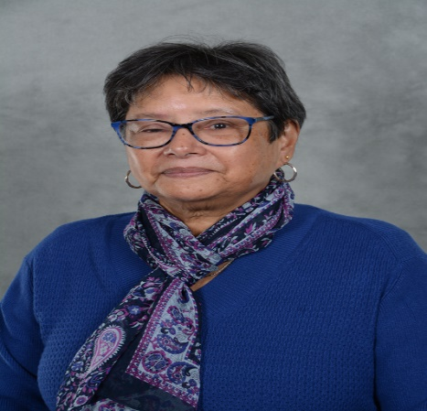
I was born in Nairobi, Kenya. My family originates from the Seychelles.
I immigrated to the UK with my family as a young child.
As a member of St Wilfrid’s and a practising Christian I have an active role in the life of our church and will complete Pastoral training this year.
I began my professional life as a teacher, working in Early Years, Primary and High Schools., mainly in Inner City schools. I made a career change some 15 years ago and trained, for 5 years as a Child and Adolescent Psychotherapist. In this role I have worked in CAMHS and Merseyside schools as a child psychotherapist. Having semi- retired, I am privileged to continue working as a child psychotherapist for Adoption / Foster Care agencies and St Luke’s Family and Counselling Services.
My leisure time is spent with family, walking, climbing and gardening.

Laura Griffiths
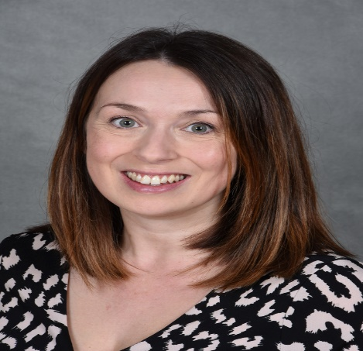
Hi! I am Laura, I have two daughters Emma (who attends Davenham Primary School) and Lola. I moved to Northwich 7 years ago with my husband Jamie and we became part of the St Wilfrid’s Church family. I currently work for Innovate UK, the UKs innovation agency which provides funding to help companies to develop new products and services. I specifically support organisations that manufacture medicines by understanding funding needs. This support allows companies to grow, employ more staff and develop lifesaving medicine within the UK.

Prior to my current role I gained my PhD at the University of Manchester studying Biochemistry, and then worked in several pharmaceutical companies, where I made medicines for both humans and animals. I love science and I am a keen STEM ambassador and equality, diversity and inclusion advocate. We certainly need more young people, from all backgrounds, to pursue a career in science.

I have undertaken the role as a Foundation School Governor as I would like to ensure that all teaching staff are supported in delivering the school vision, and that all school children receive the best education possible within a Church ethos environment. Whilst I am new to the role, I am very keen to support and always happy to engage, and I welcome any parent, staff or student to reach out to me at any time.

Gemma Laverty

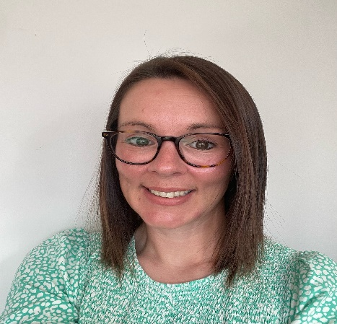

I have lived in Davenham for 11 years with my husband and two children, who both currently attend Davenham Primary school. I started working for an independent charity in August 2020 that finds, places, and supports skilled volunteers as governors and trustees on school and academy boards. Prior to this I spent 19 years working in the travel industry and was based in locations across France, Italy, and Holland, when I settled back in the UK I moved into the recruitment and logistics for Eurocamp, before joining Flight Centre as an account manager.
I applied to be a parent governor as I want to help our school provide the best environment and learning outcomes for our children.

Heather Cox

Hi, my name is Heather Cox and I have been a foundation governor since the summer of 2022. I am a senior commissioning nurse for the complex care LD and Autism team for Cheshire and Merseyside ICB. I have been a registered nurse for 6 years now and I love how many opportunities nursing can provide.
I have two children who are 4 and 2 and they very much keep me on me on my toes. In my spare time I enjoy hiking with my husband and generally being outdoors with my family.

I wanted to be a governor as I am really passionate about education but also how a good school environment can provide so much more to children than just education and I really wanted to be a part of that. I wanted to support a school community in looking holistically to pupil’s health and well-being.
I am going to support with early years as a subgroup and I am excited for this new chapter.

Kathryn Schofield

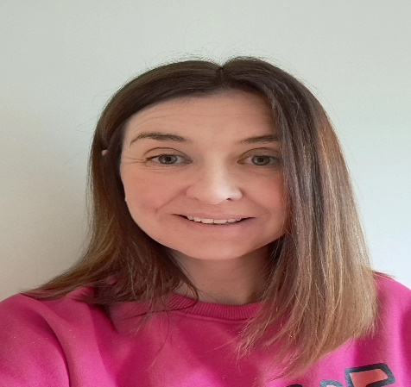

Hi everyone! My name is Kathryn and I live in Davenham with my husband and 2 children, one of whom is at Davenham. We have lived in the area all of our lives and love the village and community we share.

I work in the NHS near Manchester as a Consultant Clinical Psychologist. I lead a number of services and staff and am interested in thinking about how people and systems work together. In my job I also work individually with people with severe and enduring mental health needs to support them to recover from their experiences and have the opportunity to lead the life they want to.

I have been a Parent Governor for about a year so far. Both my children have benefited from their time at Davenham Primary and I want to support the school and give something back. I hope that my professional training and experience can support the staff and pupils to continue to develop and ensure that everyone at the school is supported to achieve their best in all areas, not just academic but wellbeing too.
The communication between school and families is key and I hope that parents and pupils are able to approach me with anything that is concerning them.

