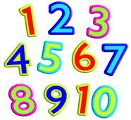
22.9.17
LO: I can recognise the place value of a 2 digit number and record this as tens and ones.

Write the number | Write it on a tens and one frame |  | Write it as tens and ones | Draw it as tens and ones
23 | T | O | 2 tens  3 ones
 | 2 | 3
tens

ones
tens

ones

